

Industrial Assessment Report AS-XXXX
Assessment Date: | Date of on-site assessment
Report Date: | Date Report is given to Lyndee
Location: | CITY, STATE ZIPCODE
Principal Products: | PRODUCT
SIC/NAICS: | XXXX/XXXXXX

PROGRAM STAFF
 | PAT PHELAN  ITAC Director  Professor of Mechanical and Aerospace Engineering  phelan@asu.edu  (480) 965-1625
 | RYAN MILCAREK  ITAC Assistant Director  Assistant Professor of Mechanical and Aerospace Engineering  ryan.milcarek@asu.edu  (480) 965-2724
SITE VISIT TEAM
PROFESSOR | TITLE (see above) | Faculty Lead
NAME | Major | Assessment Lead
NAME | Major | Equipment Lead
NAME | Major | Safety Lead
NAME | Major | Team Member
NAME | Major | Team Member

CONTRIBUTORS
Lyndee Tisinger |  | ITAC Program Manager
PROFESSOR |  | TITLE (see above)

TABLE OF CONTENTS

1. EXECUTIVE SUMMARY 6
1.1. Summary of Assessment Recommendations 6
1.2. Preface 10
1.3. Disclaimer 11
1.4. Implementation Survey Notice 11
2. FACILITY BACKGROUND 12
2.1. Private Corporate Data 12
2.2. Public Corporate Data of the Facility 12
2.3. Operating Schedule 12
2.4. Facility Layout 13
2.5. Main Process Description 14
2.6. Current Best Practices 15
2.7. Utility Usage and Cost Analysis 16
2.7.1. Summary of Utility Usage and Cost 16
2.7.2. Current Electric Rate Structure 17
2.7.3. Breakdown of Line Items on a Monthly Bill 19
2.7.4. Electrical Energy Usage and Demand 20
2.7.5. Electricity Cost Breakdown 22
2.7.6. 15-Minute Interval Demand Analysis 24
2.7.7. Natural Gas Usage and Cost 31
2.7.8. Average Usage and Demand Cost 32
2.8. Major Energy Consuming Equipment 33
2.8.1. Compressors 33
2.8.2. Refrigeration Equipment 34
2.8.3. Motors/Fans/Pumps 34
2.8.4. Boilers 34
2.9. Utility Incentives and Programs Available 35
3. ASSESSMENT RECOMMENDATIONS (ARs) 36
3.1. AR#1. RECOMMENDATION 36
3.1.1. Recommended Action 36
3.1.2. Background 37
3.1.3. Anticipated Savings 38
3.1.4. Sample Calculations 41
3.1.5. Implementation Cost 45
4. ADDITIONAL RECOMMENDATIONS 48
4.1 Generate Hydrogen on site from Ammonia. 48
4.2 Join the Demand Response Program 48
5. ADDITIONAL SUPPORT RESOURCES 49
5.1. $300,000 Implementation Cost Saving Grant 49
5.2. U.S. Department of Energy Onsite Energy Program 49
5.5 AZ MEP: Arizona Manufacturing Extension Partnership 50
5.6 Manufacture Nevada 50
5.7 ISO 50001 Energy Management Standard and the 50001 Ready Program 51
5.8. Cybersecurity 52
5.8.1 Basic Principles 52
5.8.2 Dedicate Time to Learn About Threats and Mitigation 52
5.8.3 Educate Your Employees 53
5.8.4 Consider Joining InfraGard 53
5.8.5 Employ Tools to Assess Network Security for Industrial Control Systems 54
6 DATA CONFIDENTIALITY AND DISCLOSURE 55

- EXECUTIVE SUMMARY

Summary of Assessment Recommendations

This report includes NUMBER (#) Assessment Recommendations (ARs). A brief description of each of these ARs is given below. These will be presented in more detail in Section 3.

AR#1 [INSERT AR NAME HERE] (ARC [CODE])
DESCRIPTION HERE. (example: It is recommended to install a VFD on each of the eight Clinker Cooler fans at the facility. The estimated annual savings add up to approximately $###/yr.)

AR#2 [INSERT AR NAME HERE] (ARC [CODE])
DESCRIPTION HERE.

AR#3 [INSERT AR NAME HERE] (ARC [CODE])
DESCRIPTION HERE.

AR#4 [INSERT AR NAME HERE] (ARC [CODE])
DESCRIPTION HERE.

AR#5 [INSERT AR NAME HERE] (ARC [CODE])
DESCRIPTION HERE.

AR#6 [INSERT AR NAME HERE] (ARC [CODE])
DESCRIPTION HERE.

AR#7 [INSERT AR NAME HERE] (ARC [CODE])
DESCRIPTION HERE.

The savings, implementation costs, and simple payback periods for each assessment recommendation are summarized in Table 1-1. The total cost savings of each AR are the sum of all the different cost savings associated with it. The table reveals that the total annual savings are $### whereas the total implementation cost of the NUMBER ARs is $###.

Table 1-1: Summary of Energy and Operational Savings
 | Annual Savings |  | Implementation Cost |  |  | Simple Payback (months)
 | Category | Cost Savings | Capital | Labor | Total | Simple Payback (months)
AR#1 NAME
Elect. Energy | 1,567,337 kWh/yr. | $68,962/yr. |  |  |  | 9
Elect. Demand | 2,147.7 kW-mo./yr. | $12,564/yr. |  |  |  | 9
Carbon Emission Savings | 1,084,598 lb./yr. | - |  |  |  | 9
Total | - | $81,526/yr. | $52,248 | $3,704 | $55,952 | 9
AR#2 NAME
Elect. Energy | 1,174,716 kWh/yr. | $51,688/yr. |  |  |  | 4
Elect. Demand | 1,609.2 kW-mo./yr. | $9,414/yr. |  |  |  | 4
Carbon Emission Savings | 812,904 lb./yr. | - |  |  |  | 4
Total | - | $61,102/yr. | $10,000 | $10,000 | $20,000 | 4
AR#3 NAME
Total | - | $22,882/yr. | $0 | $38 | $38 | 1
AR#4 NAME
Elect. Energy | 387,933 kWh/yr. | $17,070/yr. |  |  |  | 25
Elect. Demand | 531.2 kW-mo./yr. | $3,108/yr. |  |  |  | 25
Replacement Savings | - | -$3,653/yr. |  |  |  | 25
Carbon Emission Savings | 268,450 lb./yr. | - |  |  |  | 25
Total | - | $16,525/yr. | $31,985 | $2,442 | $34,427 | 25
AR#5 NAME
Replacement Savings | - | $5,292/yr. |  |  |  | 3
Total | - | $5,292/yr. | $800 | $108 | $908 | 3
AR#6 NAME
Elect. Energy Cost Savings | - | $123/yr. |  |  |  | 13
Elect. Demand Cost Savings | - | $369/yr. |  |  |  | 13
Total | - | $492/yr. | $0 | $511 | $511 | 13
AR#7 NAME
Elect. Energy | 9,780 kWh/yr. | $430/yr.
Carbon Emission Savings | 6,768 lb./yr. | - |  |  |  | 28
Total | - | $430/yr. | $625 | $362 | $987
 | Total Savings | $188,249/yr. |  |  | $112,823

Table 1-2 below provides a summary of the savings in electrical energy consumption and demand, replacement savings and carbon emission savings from AR#1 to AR#LAST in Table 1-1.

Table 1-2: Annual Total Savings by Category
Savings Category | Annual Savings | Annual Cost Savings
Electrical Energy | 3,129,766 kWh | $138,273
Electrical Demand | 4,288.1 kW-mo./yr. | $25,455
Replacement | - | $1,639
Other | - | $22,882
Carbon dioxide Reduction | 2,172,720 lb./yr. | -
 | Total | $188,249

It is important to note that the “law of diminishing returns” applies to the savings. Since it is not possible for our center to predict which recommendations will be implemented, each recommendation is assumed to be completely independent of the others. That is, the $###/yr. in total cost savings shown in Table 1-1 is based on the sum of the cost-saving recommendations as if each recommendation is not influenced by changes resulting from the implementation of another recommendation. Therefore, the cost savings realized by implementing more than one of the recommendations may be lower than indicated in Table 1-1 because of other implementations not accounted for in this report. The analysis presented within this report is intended as an estimate of the possible energy cost savings. Actual operations and relative savings may differ significantly.

  - Preface

This report was prepared as part of an assessment conducted under the Industrial Training and Assessment Centers (ITAC) program, a national initiative supported by the U.S. Department of Energy (DOE) through the Office of Critical Minerals and Energy Innovation (CMEI). The ITAC program consists of 36 centers across the United States, each working with manufacturers to identify opportunities for energy innovation, waste reduction, and productivity improvements.

These one-day assessments are typically performed through site visits conducted by teams of engineering faculty and students, who collect operational information, evaluate energy systems, and identify potential improvement opportunities. The program also serves an important educational mission, providing hands-on training for students.

Recommendations in this report are based on observations, measurements, and discussions with facility personnel during the assessment visit. As the assessment is generally conducted during a single-day site visit, the analysis presented in this report represents a snapshot of facility operations and may not capture every operational condition or opportunity for improvement.

The ITAC team appreciates the cooperation and assistance provided by facility personnel during the assessment process. The insights and operational knowledge shared during the visit are critical to the development of meaningful recommendations.

  - Disclaimer

The contents of this report are offered as guidance only. The analysis and recommendations contained herein represent the best effort of the Industrial Training and Assessment Center (ITAC) team at Arizona State University based on the information available at the time of the assessment. However, no warranty or guarantee is made regarding the accuracy, completeness, or suitability of the data, calculations, or recommendations presented in this report.

This report may include limited use of artificial intelligence (AI) tools to assist with [insert areas of the report that used AI]. All technical analysis, calculations, and recommendations were reviewed and validated by the ITAC team before inclusion in this report.

The recommendations provided are intended to highlight potential opportunities for energy savings, cost reduction, and operational improvements. They are not intended to serve as detailed engineering designs or final implementation plans. Facilities are encouraged to consult qualified engineering professionals, equipment vendors, or consultants when detailed engineering design or implementation support is required.

The views and conclusions expressed in this report do not necessarily reflect the official policies of the U.S. Department of Energy (DOE) or participating universities. Any mention of trade names or commercial products do not constitute endorsement or recommendation for use.

  - Implementation Survey Notice

The ASU Industrial Training and Assessment Center and the U.S. Department of Energy consider the implementation of the assessment recommendations crucial. To follow up on progress, we will contact you by telephone in eight to nine months. We'll inquire about the implementation status of the recommendations, reasons for implementation or non-implementation, and the actual costs and savings associated with each implemented recommendation. Your cooperation in providing this information is greatly appreciated.

- FACILITY BACKGROUND

  - Private Corporate Data

Your company name, contact name, email, phone number, plant address and referral information are disclosed to the ITAC national field management for verification and customer service survey purposes only.

  - Public Corporate Data of the Facility

SIC: ####
NAICS: ######
Principal products: PRODUCT
Location: CITY, STATE
Facility age: ## years
Employees: ##
Plant area: #### ft²
Annual Revenue: #### dollars
Annual Production: #### units

  - Operating Schedule

Office: Monday-Friday 8:00am-4:00pm
Production: 24 hours a day, 7 days a week
Holidays: There are no holidays observed

Table 2-1: Operating Schedules
Shift/ Location | Hours/Day | Days/Year | Holiday Hours/Year | Annual Operating Hours
Office | ## | ### | # | ####
Production floor | ## | ### | # | ####

The production floor operates for #### hours annually. The office area is occupied for ### hours annually. Hours were determined for each recommendation as applicable.

  - Facility Layout

An aerial image of the plant is presented in Figure 2-1.

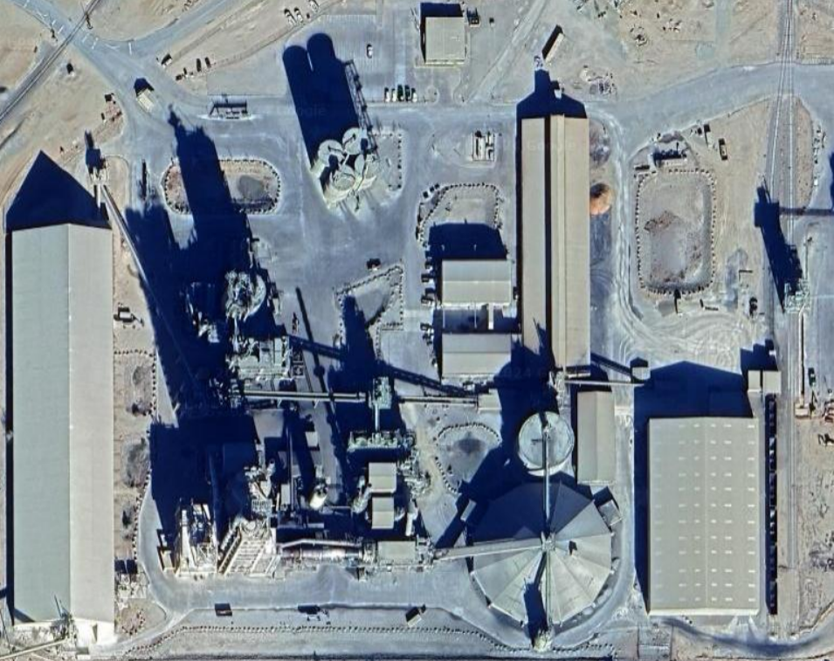
Rail Dispatch
Truck and Rail Unloading and Coal & Additive Storage
Clinker Storage and Gypsum Storage Buildings

Cement Grinding and Truck Dispatch
Material Silos
Raw Material Mixing and Clinker Production

Limestone Storage

Figure 2-1: Aerial View of the Facility. Photo from Google Satellite View.
  - Process Description

The facility produces PRODUCT. A general process flow for the facility is outlined below:

- Additives like alumina and iron are imported to the plant as minor processing additions.
- Limestone and silica are transported to the plant.
- The raw materials are stored in large silos.
- The raw ingredients are blended in proportion to prepare them for grinding.
- The raw ingredients are ground into a fine powder and are blended again to make the mixture homogenous.
- The ground mixture is fed into the kiln through a tall preheating tower, where it is heated and rapidly cooled to create clinker.
- Clinker is stored in a large dome and silo waiting to be ground into cement.
- The clinker is ground into a fine gray powder recognized as cement, adding a small amount of gypsum to control the time of setting.
- Finished cement is stored in a silo awaiting loading into trucks or rail cars.

  - Best Practices

During the site visit, several energy-efficiency projects as well as practices resulting in operational cost reduction were noted by the visiting team. To encourage the continuation of these practices, some have been outlined below:

Variable Frequency Drives on most heavy equipment: The facility has variable frequency drives installed on many of the devices present. Variable frequency drives or VFDs can help save energy by regulating the frequency of devices like pumps, fans, compressors, and motors during periods of low load to reduce energy consumption.

Energy Star Certified facility: The facility is Energy Star certified. ENERGY STAR certified buildings save energy, save money, and help protect the environment by generating fewer greenhouse gas emissions than typical buildings. To receive ENERGY STAR certification, a building must meet strict energy performance standards set by the Environmental Protection Agency. Certification is given on an annual basis, so a building must maintain its high performance to be certified year to year.

BEST PRACTICE: Description

BEST PRACTICE: Description

BEST PRACTICE: Description

  - Energy Cost Analysis

This section explains the costs and usage statistics for your utilities (energy and natural gas).

    - Summary of Utility Usage and Cost

Table 2-2: Summary of Utility Usage and Costs
Category | Annual Usage | Annual Cost ($) | Bundled Unit Cost ($)
Electrical Energy | 85,896,950 kWh | $3,777,130 | $0.0440/kWh
Electrical Demand | 298,923.0 kW-mo. | $1,749,688 | $5.85/kW-mo.
Electrical Fees/Taxes | 12 mo. | $24,567 | -
Natural Gas | 1,794,636 MMBtu | $5,718,157 | $3.19/MMBtu
Natural Gas Fees/Taxes | 12 mo. | $40,544 | -
Total | - | $11,310,086 | -

Table 2-2 summarizes the energy and natural gas usage of the facility for the billing periods between February 2022 and January 2023. Figure 2-2 shows the breakdown of the utility cost under the main categories: Electrical Energy, Electrical Demand and Electrical Fees/Taxes and Natural Gas. Natural gas is consumed in MMBtu (Metric Million British Thermal Unit).

Figure 2-2 illustrates the utility cost breakdown for the facility.

Figure 2-2: Utility Cost Breakdown

    - Current Electric Rate Structure

The plant purchases electricity through APS (Arizona Public Service utility company). The account is governed and charged according to the APS E-35 Extra Large General Service, Time of Use plan. They are charged for service at Transmission Voltage since they receive electricity at Transmission Voltage.

The rate schedule for E-35 is as follows:

This rate schedule is available to Customers whose monthly maximum demand registers 3,000 kW or more for 3 consecutive months, over the prior 12 months. This rate has three parts: a basic service charge, a demand (kW) charge, and an energy charge for the energy (kWh) used for the entire month. Both the demand charge and the energy charge will vary by the time of day that the energy is used (On-Peak or Off-Peak).
On-Peak hours are between 11:00am and 9:00pm from Monday to Friday and all remaining hours are Off-Peak. The monthly bill is calculated at the following rates or the minimum rates, whichever is greater, plus any adjustments incorporated in this rate schedule. The rates for transmission voltage are given below:

- Basic Service Charge Components:
- Customer Account: $4.050 per day
- Meter Reading: $0.010 per day
- Billing $0.032 per day
- Meter:
- Transmission Meter: $39.038 per day
- Demand Charge Components:
- Transmission Charge On-Peak: $3.236 per kW
- Generation Charge On-Peak: $7.560 per kW
- Generation Charge Off-Peak: $2.079 per kW
- Delivery (demand):
- Transmission:
- On-Peak: $0.624 per kW
- Off-Peak: $0.061 per kW
- Energy Charge Components:
- Generation On-Peak: $0.04532 per kWh
- Generation Off-Peak: $0.03540 per kWh
- System Benefits: $0.00361 per kWh

For billing kW purposes:
- The On-Peak is based on the greater of the following:
- The average kW supplied during the 15-minute period of maximum use during the billing period; or
- 80% of the highest On-Peak kW measured during May through October of the twelve months ending with the current month.
- Off-Peak is based on the average kW supplied during the 15-minute period of maximum use during Off-Peak hours.

The bill will not be less than the Basic Service Charge plus the Demand Charge for the minimum kW specified in the Customer’s service agreement or contract.

    - Breakdown of Line Items on a Monthly Bill

APS breaks down your charges depending on the service plan. In Table 2-3, we show an example of the electricity bill breakdown for December 2022.

Table 2-3: Monthly Electrical Bill Breakdown for December 2022
Description | Type of charge | Cost ($)
Customer account charge | Tax/Fee | 102.99
Demand charge on-peak – delivery | Demand | 6,811.40
Demand charge off-peak – delivery | Demand | 662.43
Environmental benefits surcharge | Usage | 10,702.01
Federal environmental improvement surcharge | Usage | 3,146.92
System benefits charge | Usage | 24,597.54
Power supply adjustment | Usage | 58,909.16
Metering | Tax/ Fee | 992.70
Meter reading | Tax/ Fee | 0.27
Billing | Tax/ Fee | 0.84
Generation of electricity on-peak | Usage | 86,254.15
Generation of electricity off-peak | Usage | 161,197.75
Demand charge on-peak – generation | Demand | 86,204.82
Demand charge off-peak – generation | Demand | 24,178.62
Federal transmission and ancillary services | Demand | 41,666.74
Federal transmission cost adjustment | Demand | -8,884.44
Regulatory assessment | Tax/ Fee | 1,008.98
State sales tax | Tax/ Fee | 0.00
County sales tax | Tax/ Fee | 0.00
City sales tax | Tax/ Fee | 0.00
Franchise fee | Tax/ Fee | 0.00
Total |  | 497,552.88

    - Electrical Energy Usage and Demand

Table 2-4 shows the total electrical energy usage (kWh) and demand (kW) from February 2022 to January 2023.

Table 2-4: Monthly Electrical Energy Usage and Demand
Month-Year | Usage (kWh) |  |  | Billed Demand (kW)
Month-Year | On-peak | Off-peak | Total | On-peak | Off-peak | Total
Feb-22 | 2,157,404 | 5,102,451 | 7,259,855 | 12,450.0 | 12,278.0 | 24,728.0
Mar-22 | 2,284,563 | 5,397,744 | 7,682,307 | 13,026.0 | 12,813.0 | 25,839.0
Apr-22 | 1,586,095 | 3,979,322 | 5,565,417 | 12,049.0 | 12,001.0 | 24,050.0
May-22 | 2,212,450 | 5,044,442 | 7,256,892 | 12,050.0 | 12,292.0 | 24,342.0
Jun-22 | 2,240,631 | 5,369,668 | 7,610,299 | 12,206.0 | 12,642.0 | 24,848.0
Jul-22 | 1,939,541 | 5,336,275 | 7,275,816 | 11,920.0 | 12,111.0 | 24,031.0
Aug-22 | 2,023,417 | 5,033,834 | 7,057,251 | 12,451.0 | 11,977.0 | 24,428.0
Sep-22 | 1,944,093 | 5,074,805 | 7,018,898 | 12,372.0 | 12,583.0 | 24,955.0
Oct-22 | 2,221,849 | 5,972,762 | 8,194,611 | 12,695.0 | 12,627.0 | 25,322.0
Nov-22 | 1,837,874 | 4,598,919 | 6,436,793 | 12,959.0 | 12,913.0 | 25,872.0
Dec-22 | 2,295,825 | 5,512,919 | 7,808,744 | 12,879.0 | 12,739.0 | 25,618.0
Jan-23 | 2,068,048 | 4,662,019 | 6,730,067 | 12,400.0 | 12,490.0 | 24,890.0
Total | 24,811,790 | 61,085,160 | 85,896,950 | 149,457.0 | 149,466.0 | 298,923.0

Figure 2-3 shows the corresponding plot for each of the 12 months from February 2022 to January 2023 respectively.

Figure 2-3: Monthly Electricity Usage

    - Electricity Cost Breakdown

The monthly cost breakdown of electricity for the meter is shown in Table 2-5a, Table 2-5b and Table 2-5c.

Table 2-5a: Monthly Electricity Costs (Usage)
Month-Year | Usage Cost ($)
Month-Year | On-peak | Off-peak | Additional | Total
Feb-22 | 81,054 | 149,196 | 88,189 | 318,439
Mar-22 | 85,831 | 157,830 | 93,108 | 336,769
Apr-22 | 59,590 | 116,355 | 69,953 | 245,898
May-22 | 83,122 | 147,499 | 88,729 | 319,350
Jun-22 | 84,181 | 157,009 | 93,138 | 334,328
Jul-22 | 72,869 | 156,033 | 89,286 | 318,188
Aug-22 | 76,020 | 147,189 | 87,126 | 310,335
Sep-22 | 73,040 | 148,387 | 86,664 | 308,091
Oct-22 | 83,475 | 174,644 | 99,878 | 357,997
Nov-22 | 69,049 | 134,472 | 80,503 | 284,024
Dec-22 | 86,254 | 161,198 | 97,356 | 344,808
Jan-23 | 77,697 | 136,317 | 84,889 | 298,903
Total | 932,182 | 1,786,129 | 1,058,819 | 3,777,130

Table 2-5b: Monthly Electricity Costs (Demand)
Month-Year | Billed Demand Cost ($)
Month-Year | On-peak | Off-peak | Additional | Total
Feb-22 | 89,939 | 23,942 | 31,212 | 145,093
Mar-22 | 94,100 | 24,985 | 32,656 | 151,741
Apr-22 | 87,042 | 23,402 | 30,207 | 140,651
May-22 | 87,049 | 23,969 | 30,209 | 141,227
Jun-22 | 88,176 | 24,652 | 31,076 | 143,904
Jul-22 | 86,110 | 23,616 | 30,348 | 140,074
Aug-22 | 89,946 | 23,355 | 31,700 | 145,001
Sep-22 | 89,375 | 24,537 | 31,499 | 145,411
Oct-22 | 91,709 | 24,623 | 32,321 | 148,653
Nov-22 | 93,616 | 25,180 | 32,994 | 151,790
Dec-22 | 93,016 | 24,841 | 32,782 | 150,639
Jan-23 | 89,578 | 24,356 | 31,570 | 145,504
Total | 1,079,656 | 291,458 | 378,574 | 1,749,688

Table 2-5c: Monthly Electricity Costs (Total)
Month-Year | Total Usage Cost ($) | Total Demand Cost ($) | Taxes/Fees ($) | Total Cost ($)
Feb-22 | 318,439 | 145,093 | 2,004 | 465,536
Mar-22 | 336,769 | 151,741 | 2,055 | 490,565
Apr-22 | 245,898 | 140,651 | 1,958 | 388,507
May-22 | 319,350 | 141,227 | 2,035 | 462,612
Jun-22 | 334,328 | 143,904 | 2,071 | 480,303
Jul-22 | 318,188 | 140,074 | 2,104 | 460,366
Aug-22 | 310,335 | 145,001 | 1,988 | 457,324
Sep-22 | 308,091 | 145,411 | 2,021 | 455,523
Oct-22 | 357,997 | 148,653 | 2,165 | 508,815
Nov-22 | 284,024 | 151,790 | 1,948 | 437,762
Dec-22 | 344,808 | 150,639 | 2,106 | 497,553
Jan-23 | 298,903 | 145,504 | 2,112 | 446,519
Total | 3,777,130 | 1,749,688 | 24,567 | 5,551,385

Figure 2-4 shows the corresponding plot for each of the 12 months from February 2022 to January 2023.

Figure 2-4: Monthly Electricity Usage and Demand Cost

    - 15-Minute Interval Demand Analysis

You provided the ITAC team with data containing the average demand, in kW, for every 15-minute interval of the last year. The energy for the facility is split between two buses, Bus A and Bus B. This data enables the ITAC team to gain valuable insights into your usage patterns. Figure 2-5a and Figure 2-5b below show a histogram of daily peak demands from June 2022 through May 2023, for the two buses. Note that the bar corresponding to ‘9AM’ reflects the number of times that the maximum peak demand for the day occurred between 9am and 10am, the bar corresponding to ‘10AM’ reflects the number of times that the maximum peak demand for the day occurred between 10am and 11am, and so on.

Figure 2-5a: Frequency Distribution of Daily Peak Demands for Bus A

Figure 2-5b: Frequency Distribution of Daily Peak Demands for Bus B

Table 2-6 below gives the monthly peak demand, for the corresponding 15-minute intervals.

Table 2-6: Observed Monthly Peak Demands and When They Occurred
Billing Period |  | Bus A Peak Demand (kW) | Bus B Peak Demand (kW) | Date for Bus A | Date for Bus B | Time for Bus A | Time for Bus B
06/1/2022 | 06/30/2022 | 0.0 | 7,584.7 | 06/01/2022 | 06/21/2022 | 12:00 AM | 04:00 AM
07/1/2022 | 07/31/2022 | 6,388.0 | 7,922.1 | 07/29/2022 | 07/12/2022 | 12:45 PM | 07:45 PM
08/1/2022 | 08/31/2022 | 6,118.1 | 8,026.0 | 08/05/2022 | 08/21/2022 | 02:45 PM | 09:45 PM
09/1/2022 | 09/30/2022 | 6,670.3 | 8,202.2 | 09/06/2022 | 09/10/2022 | 11:00 AM | 06:30 PM
10/1/2022 | 10/31/2022 | 6,639.3 | 8,105.8 | 10/28/2022 | 10/25/2022 | 02:45 PM | 03:45 AM
11/1/2022 | 11/30/2022 | 6,394.8 | 8,035.4 | 11/19/2022 | 11/29/2022 | 11:45 AM | 04:00 PM
12/1/2022 | 12/31/2022 | 6,533.2 | 7,657.8 | 12/13/2022 | 12/10/2022 | 07:15 AM | 08:30 AM
01/1/2023 | 01/31/2023 | 6,356.3 | 8,079.8 | 01/26/2023 | 01/30/2023 | 01:45 PM | 06:00 PM
02/1/2022 | 02/28/2023 | 6,161.9 | 7,984.7 | 02/01/2023 | 02/15/2023 | 06:15 PM | 11:15 PM
03/1/2022 | 03/31/2023 | 6,112.5 | 7,327.2 | 03/02/2023 | 03/01/2023 | 12:00 PM | 07:15 PM
04/1/2022 | 04/30/2023 | 6,456.5 | 7,834.3 | 04/22/2023 | 04/28/2023 | 08:00 AM | 05:00 AM
05/1/2022 | 05/31/2023 | 6,181.2 | 7,983.7 | 05/01/2023 | 05/07/2023 | 07:00 AM | 03:30 PM

The graphs in Figures 2-6(a), 2-6(b), 2-6(c) and 2-6(d) below show us the average peak demand for each 15-minute interval for each day of the week of each month. In other words, for the graph corresponding to January, a single point along the x-axis gives us the average kW value measured during that 15-minute interval for the entire month for each day of the week.

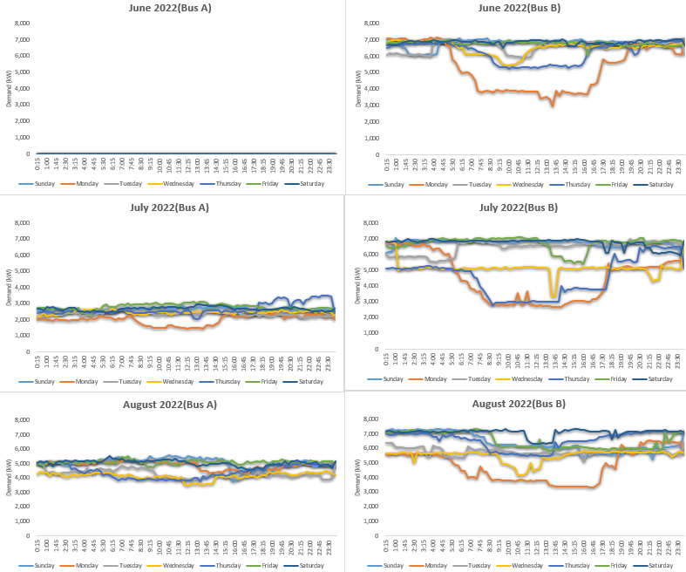

Figure 2-6(a): Average Peak Demands by Interval, Weekday, and Month from Jun’22 to Aug’22

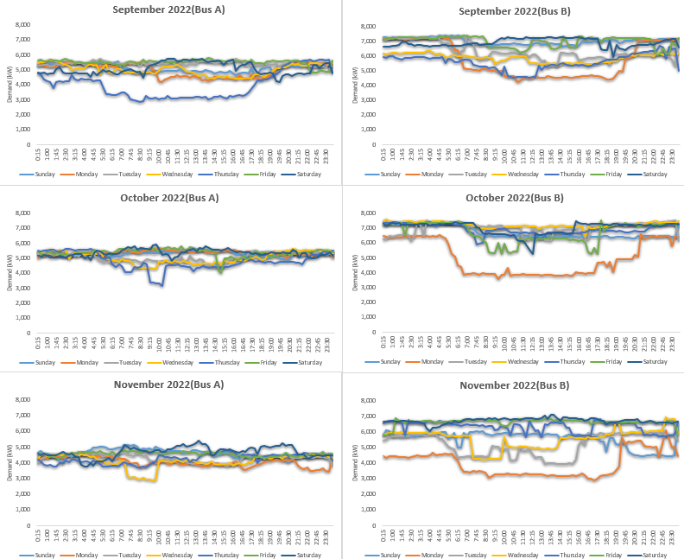

Figure 2-6(b): Average Peak Demands by Interval, Weekday, and Month from Sep’22 to Nov’22

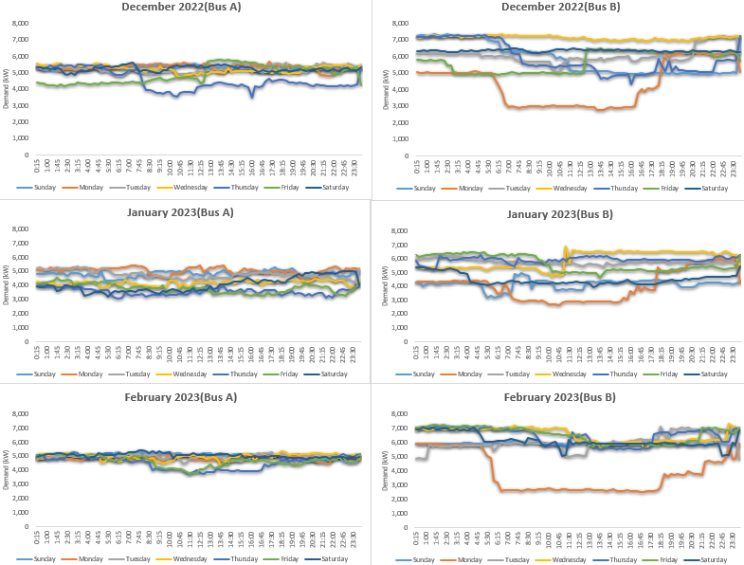

Figure 2-6(c): Average Peak Demands by Interval, Weekday, and Month from Dec’22 to Feb’23

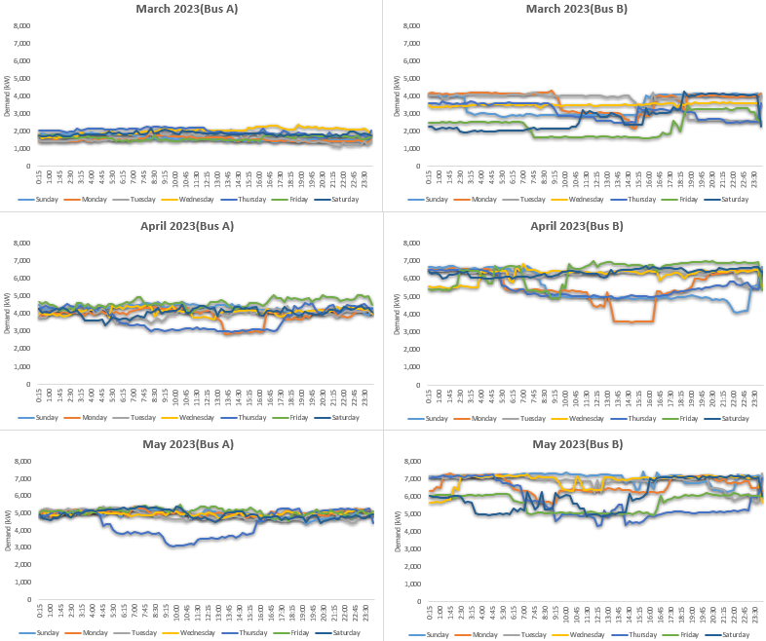

Figure 2-6(d): Average Peak Demands by Interval, Weekday, and Month from Mar’23 to May’23

From the above graphs it is evident that Bus A is more consistent while Bus B tends to have more variation. Mondays tend to have a dip in demand during daytime. Also, data was missing for March between the 14th and the 22nd in 2023. For Bus A, data was missing until the 14th of July in 2022. This is the reason why the month of March has low demand values, and the month of June is blank for Bus A.
    - Natural Gas Usage and Cost

Table 2-7 below shows the natural gas usage and cost for the facility from February 2022 to January 2023.

Table 2-7: Natural gas usage and cost
Month-Year | Natural Gas Usage (MMBTU) | Cost ($) | Taxes/Fees ($) | Late Fees ($) | Total Cost ($)
Feb-22 | 105,025 | 361,585 | 1,246 | - | 362,831
Mar-22 | 106,243 | 349,572 | 1,220 | 5,454 | 356,246
Apr-22 | 136,072 | 380,561 | 1,288 | 5,355 | 387,204
May-22 | 120,807 | 410,549 | 1,354 | 5,821 | 417,724
Jun-22 | 156,922 | 513,009 | 1,580 | - | 514,589
Jul-22 | 151,784 | 437,480 | 1,413 | - | 438,893
Aug-22 | 145,349 | 414,626 | 1,322 | - | 415,948
Sep-22 | 161,221 | 537,273 | 1,579 | 6,252 | 545,104
Oct-22 | 159,565 | 484,450 | 1,466 | 8,194 | 494,110
Nov-22 | 187,727 | 668,582 | 1,855 | 500 | 670,937
Dec-22 | 142,242 | 499,790 | 1,501 | -8,694 | 492,597
Jan-23 | 221,679 | 660,680 | 1,838 | - | 662,518
Total | 1,794,636 | 5,718,157 | 17,662 | 22,882 | 5,758,701

Figure 2-7 shows the plot of natural gas consumption and the associated cost for each of the 12 months from February 2022 to January 2023.

Figure 2-7: Monthly Natural Gas Usage and Charges

    - Average Usage and Demand Cost

The bundled utility charges for your facility were calculated for electrical energy usage and billed demand using Tables 2-4, 2-5a and 2-5b and for natural gas using Table 2-7 as follows:

Bundled Usage Cost:
$=\frac{Total Annual Cost of Electrical Energy}{Total Annual Electrical Usage}=\frac{\$3,777,130}{85,896,950 kWh}= \$0.0440/kWh$

Bundled On-Peak Usage Cost:
$=\frac{Total Annual Cost of On-Peak Electrical Energy}{Total Annual On-Peak Electrical Usage}=\frac{\$932,182}{24,811,790 kWh}= \$0.0376/kWh$

Bundled Off-Peak Usage Cost:
$=\frac{Total Annual Cost of Off-Peak Electrical Energy}{Total Annual Off-Peak Electrical Usage}=\frac{\$1,786,129}{61,085,160 kWh}= \$0.0292/kWh$

Bundled Demand Cost:
$=\frac{Total Annual Billed Demand Cost}{Total Annual Billed Demand}=\frac{\$1,749,688}{298,923.0 kW-mo.}= \$5.85/kW$

Bundled On-Peak Demand Cost:
$=\frac{Total Annual Billed On-Peak Demand Cost}{Total Annual Billed On-Peak Demand}=\frac{\$1,079,656}{149,457.0 kW-mo.}= \$7.22/kW$

Bundled Off-Peak Demand Cost:
$=\frac{Total Annual Billed Off-Peak Demand Cost}{Total Annual Billed Off-Peak Demand}=\frac{\$291,458}{149,466.0 kW-mo.}= \$1.95/kW$

Bundled Natural Gas Usage Cost:
$=\frac{Total Annual Billed Natural Gas Cost}{Total Annual Billed Natural Gas Usage}=\frac{\$5,718,157}{1,794,636 MMBTU}= \$3.19/MMBTU$

These bundled unit costs are used throughout the report to estimate the cost savings that can be attained for each assessment recommendation. The bundled costs for on-peak and off-peak energy are used for AR#6 exclusively.

  - Major Energy Consuming Equipment

Although the facility provided the ITAC with an extensive equipment list, only the equipment relevant to the ARs in this report has been included in this section to try and keep it brief.

    - Compressors

Table 2-8 gives a summary of the compressors in use at the facility.

Table 2-8: Summary of Compressors
Equipment | Horsepower | Maximum Operating Pressure (psig) | Annual hrs. of operation
NAME | Rated HP (Nameplate) | Gage Pressure (Nameplate) | From site personnel
NAME | Rated HP (Nameplate) | Gage Pressure (Nameplate) | From site personnel

    - Refrigeration Equipment

Table 2-9 gives a summary of the EQUIPMENT in the facility.

Table 2-9: Summary of EQUIPMENT
Equipment | Load (tons) | Operating Hours | Load Factor
NAME | NUMBER (nameplate or personnel) | NUMBER (Personnel) | NUMBER (Data Loggers or Personnel)
NAME | NUMBER (nameplate or personnel) | NUMBER (Personnel) | NUMBER (Data Loggers or Personnel)

    - Motors/Fans/Pumps

Table 2-10 gives a summary of the EQUIPMENT in use at the facility.

Table 2-10: Summary of EQUIPMENT
Equipment Number | Horsepower | Operating Hours | Load Factor
NUMBER/NAME | NUMBER (Nameplate) | NUMBER (Personnel) | NUMBER (Data Loggers or Personnel)

    - Boilers

Table 2-11 gives a summary of the EQUIPMENT in use at the facility.

Table 2-11: Summary of EQUIPMENT
Equipment | Horsepower (hp) | Capacity (MMBTU/hr) | Operating Hours
NUMBER/NAME | NUMBER (Nameplate or Personnel) | NUMBER (Nameplate or Personnel) | NUMBER (Personnel)

  - Utility Incentives and Programs Available

APS offers rebates for commercial customers including some prescriptive options. Listed here are rebates relevant to the assessment recommendations discussed in this report along with some others that may be of interest to your facility. The rebates only apply to new purchases, and you should contact your APS account manager before making any purchases. Below is the list of relevant APS rebates:
- Lighting:
  - Linear LED: 2-ft, 3-ft, 4-ft, 8-ft $3/lamp
  - LED exit sign: $15/sign
  - Outdoor LED ≤ 50W: $20/fixture
  - Outdoor LED > 50W: < 300W $35/fixture
  - Outdoor LED ≥ 300W: $50/fixture
- Variable Frequency Drives
  - Process motor: $35 per horsepower

- ASSESSMENT RECOMMENDATIONS (ARs)

  - AR-1. RECOMMENDATION

    - Recommended Action

It is recommended to RECOMMENDATION. The savings and costs associated with this recommendation can be seen in Table 3-1.1.

Table 3-1.1: AR-1 Recommendation Summary
Estimated Savings
Electricity Usage | 1,567,337 kWh/yr
Electricity Demand | 2,147.7 kW-mo/yr
Carbon Emission Savings | 1,084,598 lb/yr
Estimated Cost Savings
Electricity Usage Cost Savings | $68,962/yr
Electricity Demand Cost Savings | $12,564/yr
Estimated Total Energy Cost Savings | $81,526/yr
Estimated Implementation Cost and Payback
Capital Cost (Rebate applied) | $52,248
Labor Cost | $3,704
Estimated Total Implementation Cost | $55,952
Simple Payback Period | 9 Months

    - Background

In many commercial and industrial environments, the application of RECOMMENDATION is used to reduce energy usage and increase savings. This occurs because HOW RECOMMENDATION SAVES ELECTRICITY/MONEY. In your case, this recommendation is applicable WHERE IS THE APPLICATION APPLICABLE. Below we have performed the calculations to determine your savings.

In Table 3-1.2 we have included a summary of the equipment that will benefit from this recommendation.

Table 3-1.2: Summary of EQUIPMENT
Equipment | Horsepower | Operating Hours | Average Current (A) | Maximum Current (A) | Load Factor (%)
NAME | 150 | 8,232 | 103.7 | 116.0 | 89
NAME | 100 | 8,232 | 77.7 | 90.5 | 86
NAME | 125 | 8,232 | 115.1 | 130.7 | 88

In the next section, the anticipated savings of implementing this recommendation are calculated.

    - Anticipated Savings

The affinity laws estimate that the change in power on the motor varies as the cube of the speed of the motor, or flow as follows:

$$\frac{{Power}_{current}}{{Power}_{proposed}}={\left[\frac{{Speed}_{c}}{{Speed}_{p}}\right]}^{3}={\left[\frac{{Flow}_{c}}{{Flow}_{p}}\right]}^{3}$$

This relationship is used to estimate the energy use of a given motor with a variable frequency drive. Table 3-1.3 below shows the relative power consumption of a motor using VFD control, compared to a motor with standard controls. Notice that the affinity laws are not exactly followed for VFD power consumption. This is a result of losses incurred by the variable frequency drive, which reduces the motor’s efficiency. Therefore, with VFD control, as the flow rate decreases the VFD/motor system efficiency decreases. Consequently, the actual power consumption is higher than the theoretical power consumption estimated by the affinity laws with more deviation at lower flow rates.

Table 3-1.3: Percent of Rated Load with VFD Control
Load Factor % | Power Consumption of Motor
Load Factor % | No Control % | VFD %
100 | 100 | 105
95 | 95 | 86
90 | 90 | 73
85 | 85 | 64
80 | 80 | 57
75 | 75 | 50
70 | 70 | 44
65 | 65 | 38
60 | 60 | 32
55 | 55 | 26
50 | 50 | 21
45 | 45 | 17
40 | 40 | 14
35 | 35 | 11
30 | 30 | 8
25 | 25 | 6
20 | 20 | 5

The amperage data for the fans was used to calculate their respective load factors. This data was provided by the facility. The load factor for Fan 1 was found to be 89% from Equation 3.1.1 below. According to Table 3-1.3, the power consumption with a VFD for Fan 1 is between 64% and 73% and was linearly interpolated to find the final value of 71.2%. This value will be used as the proposed power consumption for Fan 1 with a VFD for future calculations. The load factor for each of the other fans was evaluated in a similar manner. These load factors have been listed in Table 3-1.2.

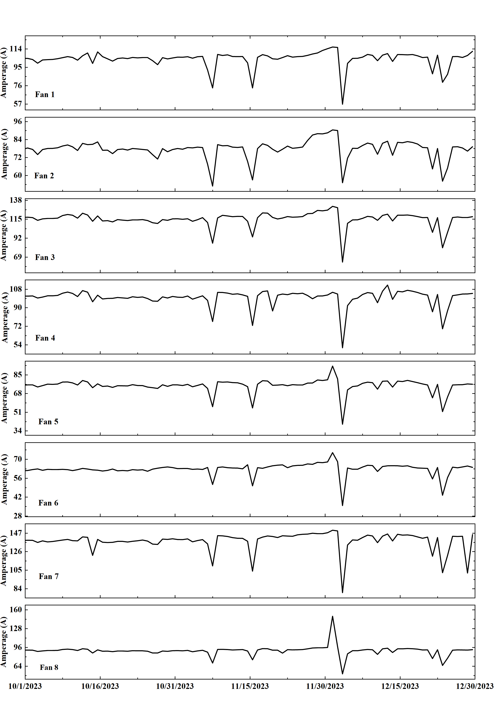

Figure 3-1.1: Amperage Data for the EQUIPMENT

    - Sample Calculations

The following calculations are for Fan 1:

1) Operating Load Factor

The average load factor, $LF$, is determined using Equation 3.1.1 below:

$LF = \frac{I_{average}}{I_{maximum}}×100$ Eq – 3.1.1

where $I_{average}$ is the average amperage recorded for the device and $I_{maximum}$ is the maximum amperage recorded for the device. Plugging in the appropriate values we get:

$LF =\frac{103.7}{116.0}×100$

$LF=89\%$

2) Annual Usage Savings

The annual usage savings, $US$, is determined using Equation 3.1.2:

$US = \frac{HP× C_{2}×\left(PC_{cur}-PC_{VFD}\right)×OH}{η_{motor}}$ Eq – 3.1.2

where $PC_{VFD}$ and $PC_{cur}$ are the proposed power consumption with a VFD and the current power consumption without a VFD at the current load factor based on Table 3-1.3 respectively, $HP$ is the horsepower of the device, $C_{2}$ is a conversion factor from horsepower to kilowatt, $η_{motor}$ is the efficiency of the device’s motor (conservatively estimated to be 90% based on average motor efficiencies) and $OH$ is the annual operating hours of the device.
Plugging in the appropriate values, we obtain the following:
$$US =\frac{150hp× 0.746\frac{kW}{hp}×\left(0.89-0.712\right)× LINK Excel.Sheet.12 "C:\backslash \backslash Users\backslash \backslash lsiwek\backslash \backslash Dropbox\backslash \backslash Automated AR Templates\backslash \backslash 2.4 Motor Systems\backslash \backslash VFD - Compressor.xlsx" Sheet1!OH \backslash a \backslash t \backslash * MERGEFORMAT 8,232 \frac{hr}{yr} }{0.90}$$

$US=182,185 \frac{kWh}{yr}$

3) Usage Cost Savings

The annual usage cost savings, $UCS$, is determined using Equation 3.1.3:

$UCS = US× UC$ Eq – 3.1.3

where $US$ is the annual usage savings and $UC$ is the bundled usage charge for the facility.
Plugging in the appropriate values, we obtain the following:

$$UCS = LINK Excel.Sheet.12 "C:\backslash \backslash Users\backslash \backslash lsiwek\backslash \backslash Dropbox\backslash \backslash Automated AR Templates\backslash \backslash 2.4 Motor Systems\backslash \backslash VFD - Compressor.xlsx" Sheet1!US \backslash a \backslash t \backslash * MERGEFORMAT 182,185 \frac{kWh}{yr} ×\frac{\$0.0440}{kWh}$$

$UCS =\frac{\$8,016}{yr}$

4) Demand Savings

The annual demand savings, $DS$, is determined using Equation 3.1.4:

$DS =\frac{US×M×CF}{OH}$ Eq – 3.1.4

where $M$ is the number of operational months in a year, and $CF$ is the coincidence factor that the savings will occur during the peak demand hours (calculated as 0.94 by dividing the device’s operating hours by the facility’s operating hours). Plugging in the appropriate values, we obtain the following:

$$DS =\frac{182,185 \frac{kWh}{yr}×12\frac{mo}{yr}×0.94}{8,232}$$

$DS = LINK Excel.Sheet.12 "C:\backslash \backslash Users\backslash \backslash lsiwek\backslash \backslash Dropbox\backslash \backslash Automated AR Templates\backslash \backslash 2.4 Motor Systems\backslash \backslash VFD - Compressor.xlsx" Sheet1!DS \backslash a \backslash t \backslash * MERGEFORMAT 249.6 \frac{kW-mo}{yr}$

5) Demand Cost Savings

The annual demand cost savings, $DCS$, is determined using Equation 3.1.5:

$DCS = DS×DC$ Eq – 3.1.5

where $DS$ is the annual demand savings and $DC$ is the bundled demand charge for the facility.
Plugging in the appropriate values, we obtain the following:

$$DCS = LINK Excel.Sheet.12 "C:\backslash \backslash Users\backslash \backslash lsiwek\backslash \backslash Dropbox\backslash \backslash Automated AR Templates\backslash \backslash 2.4 Motor Systems\backslash \backslash VFD - Compressor.xlsx" Sheet1!DS \backslash a \backslash t \backslash * MERGEFORMAT 249.6 \frac{kW-mo}{yr} × \$\frac{5.85}{kW-mo}$$

$$DCS =\frac{\$1,460}{yr}$$

6) Total Cost Savings

The total annual cost savings, $TCS$, is determined using Equation 3.1.6:

$TCS= UCS+DCS$ Eq – 3.1.6

where $UCS$ is the annual usage cost savings and $DCS$ is the annual demand cost savings. Plugging in the appropriate values, we obtain the following:

$$TCS =\frac{\$8,016}{yr}+\frac{\$ LINK Excel.Sheet.12 "C:\backslash \backslash Users\backslash \backslash lsiwek\backslash \backslash Dropbox\backslash \backslash Automated AR Templates\backslash \backslash 2.4 Motor Systems\backslash \backslash VFD - Compressor.xlsx" Sheet1!DCS \backslash a \backslash t \backslash * MERGEFORMAT 1,460 }{yr}$$

$$TCS =\frac{\$9,476}{yr}$$

7) Annual Carbon Emission Savings

Another important saving to consider is the resulting carbon dioxide (CO₂) savings from a powerplant not needing to produce the additional kWh to power a motor without a VFD. Therefore, the carbon emission savings, $CES$, can be calculated using Equation 3.1.7:

$CES=US ×EF$ Eq – 3.1.7

where $EF$ is the emission factor, or the amount of CO₂ generated per kWh by Arizona powerplants (0.692 pounds per kWh). Plugging in the appropriate values, we obtain the following:

$$CES= LINK Excel.Sheet.12 "C:\backslash \backslash Users\backslash \backslash lsiwek\backslash \backslash Dropbox\backslash \backslash Automated AR Templates\backslash \backslash 2.4 Motor Systems\backslash \backslash VFD - Compressor.xlsx" Sheet1!US \backslash a \backslash t \backslash * MERGEFORMAT 182,185 \frac{kWh}{yr} ×0.692\frac{lb}{kWh}$$

$$CES=126,072\frac{lb}{yr}$$
These equations were used to calculate the savings for the rest of the fans as well. Table 3-1.4 summarizes the annual savings for all the clinker cooler fans.

Table 3-1.4: Summary of Annual Savings
Equipment | Usage Savings (kWh/yr) | Usage Cost Savings ($) | Demand Savings (kW-mo/yr) | Demand Cost Savings ($) | Total Cost Savings ($) | Carbon Emission Savings (lb/yr)
Clinker Cooler Fan Number 1 | 182,185 | 8,016 | 249.6 | 1,460 | 9,476 | 126,072
Clinker Cooler Fan Number 2 | 137,833 | 6,065 | 188.9 | 1,105 | 7,170 | 95,380
Clinker Cooler Fan Number 3 | 158,644 | 6,980 | 217.4 | 1,272 | 8,252 | 109,782
Clinker Cooler Fan Number 4 | 182,185 | 8,016 | 249.6 | 1,460 | 9,476 | 126,072
Clinker Cooler Fan Number 5 | 192,761 | 8,481 | 264.1 | 1,545 | 10,026 | 133,391
Clinker Cooler Fan Number 6 | 146,021 | 6,425 | 200.1 | 1,171 | 7,596 | 101,047
Clinker Cooler Fan Number 7 | 188,326 | 8,286 | 258.1 | 1,510 | 9,796 | 130,322
Clinker Cooler Fan Number 8 | 379,382 | 16,693 | 519.9 | 3,041 | 19,734 | 262,532
Total | 1,567,337 | 68,962 | 2,147.7 | 12,564 | 81,526 | 1,084,598

    - Implementation Cost

To implement this recommendation, VFDs will need to be purchased for each of the fans. The average cost of a VFD suited for the rated horsepower of the fans has been summarized in Table 3-1.5.

Table 3-1.5: Summary of Average VFD Costs
Horsepower | Average Cost ($)
200 | 10,216
150 | 13,546
125 | 12,123
100 | 10,364

APS offers a rebate of $35 per unit horsepower for process motors. Therefore, using the price of the VFD, the rebate amount and the cost of labor, the implementation cost calculations for Fan 1 can be determined as shown below:

The capital cost CC is determined using Equation 3.1.8:

$CC=C_{VFD}-(HP×R_{rebate})$ Eq – 3.1.8

where, $C_{VFD}$ is the average cost of a VFD suited for the device’s horsepower rating and $R_{rebate}$ is the rebate rate offered by the utility company. Capital cost is zero if the rebate offered is greater than the capital cost. Plugging in the appropriate values, we obtain the following:

$$CC=\$13,546-(150 hp×\frac{\$35}{hp})$$

$$CC=\$8,296$$

The labor cost,$LC$, is determined using Equation 3.1.9:

$LC=LCh×TR$ Eq – 3.1.9

where $LCh$ is the labor rate per hour and $TR$is the time to install and program a VFD (estimated to be 15 hours). Plugging in the appropriate values, we obtain the following:

$$LC=\$30.86×15 h= \$463$$

Therefore, the total implementation cost, $TIC$, is obtained using Equation 3.1.10:

$TIC=CC+LC$ Eq – 3.1.10

Plugging in the appropriate values, we obtain the following:

$$TIC= \$8,296 + \$463 = \$8,759$$

The implementation cost for installing a VFD on the other fans was evaluated using the same method. The implementation cost details for the fans have been summarized in Table 3-1.6.

Table 3-1.6: Summary of Implementation Costs
Equipment | VFD Cost ($) | Rebate ($) | Capital Cost ($) | Labor Cost ($) | Total Implementation Cost ($)
Clinker Cooler Fan Number 1 | 13,546 | 5,250 | 8,296 | 463 | 8,759
Clinker Cooler Fan Number 2 | 10,364 | 3,500 | 6,864 | 463 | 7,327
Clinker Cooler Fan Number 3 | 12,123 | 4,375 | 7,748 | 463 | 8,211
Clinker Cooler Fan Number 4 | 13,546 | 5,250 | 8,296 | 463 | 8,759
Clinker Cooler Fan Number 5 | 12,123 | 4,375 | 7,748 | 463 | 8,211
Clinker Cooler Fan Number 6 | 10,364 | 3,500 | 6,864 | 463 | 7,327
Clinker Cooler Fan Number 7 | 10,216 | 7,000 | 3,216 | 463 | 3,679
Clinker Cooler Fan Number 8 | 10,216 | 7,000 | 3,216 | 463 | 3,679
Total | 92,498 | 40,250 | 52,248 | 3,704 | 55,952

Thus, the total implementation cost comes to $55,952 with an annual cost savings of $81,526. The payback period for implementing this recommendation is calculated as follows:

$\frac{\$55,952}{ \$81,526} × 12 months= 9 months$

- ADDITIONAL RECOMMENDATIONS

  - Generate Hydrogen on site from Ammonia.

Hydrogen should be generated on site from Ammonia. This can be done either using the waste heat from the kiln or by using a solar concentrator to generate heat. A catalyst will also be required to break down the ammonia along with the heat supplied. The hydrogen generated can be used as a substitute for the natural gas used. It burns cleaner than natural gas and can have a high impact on the plant’s emissions,.

  - Join the Demand Response Program

It might be beneficial to join the demand response program offered by APS. APS charges you an extra 25 cents for each kWh you use during a demand response event, but they offer a minor discount of 0.7 cents for every other kWh used in summer. Turning off the pump system does not generate any income by itself. Larger machinery needs to be turned off in addition to the pump system to make participating in this program lucrative for the facility.

- ADDITIONAL SUPPORT RESOURCES

  - $300,000 Implementation Cost Saving Grant

Under the Infrastructure Investment and Jobs Act, by having an energy assessment from an Industrial Training and Assessment Center, you could be eligible for a grant up to $300,000 (50 percent cost-share) through the Department of Energy. This grant can be used to: improve energy efficiency; material efficiency; cybersecurity; or productivity; or reduce waste production; greenhouse gas emissions; or non-greenhouse gas pollution. Currently this grant is on hold and is listed here for reference purposes if the program resumes.

  - U.S. Department of Energy Onsite Energy Program

The U.S. Department of Energy’s (DOE) Onsite Energy Technical Assistance Partnerships (TAPs) help industrial and other large energy users transition to clean energy, lower costs, reduce emissions, and contribute to a clean energy economy. Onsite energy refers to electric and thermal energy generation and storage technologies that are physically located at an industrial facility or other large energy users and provide clean energy services directly to their site. Large energy users can include campuses, hospitals, and other sites with significant energy loads year-round. Optony operates the Western Region Technical Assistance Partnership and will screen your site for opportunities and help craft an onsite energy strategy to maximize economic impact, reduce risk, and minimize operations and maintenance costs. The Onsite Energy Program is part of a broad portfolio of technical assistance programs at DOE that are designed to help facilities become more energy efficient, reduce emissions, and plan for future energy needs. Other programs include Better Plants and Better Buildings Program.

  - AZ MEP: Arizona Manufacturing Extension Partnership



AZ MEP is Arizona’s Manufacturing Extension Partnership and part of the national MEP network. AZ MEP’s mission is to help make every Arizona manufacturer the most successful business it can be. AZ MEP provides services to manufacturers across the state and is committed to helping their clients achieve their business and operational goals with a focus on top and bottom-line growth, operational excellence, supply chain optimization, organizational development, and deployment of advanced technologies. As an ITAC partner, AZ MEP can provide technical assistance in the implementation of key initiatives identified through the industrial assessment process. To learn more please visit www.azmep.org or call 602.845.1256.

  - Manufacture Nevada


Manufacture Nevada is the official representative of the MEP National Network in Nevada. Their mission is to help Nevada manufacturers navigate their path to success by providing dedicated advisors advocating for manufacturers. These advisors work with each company to provide resources, training, and possibilities through meaningful partnerships. Manufacture Nevada helps develop processes to increase efficiency, quality, safety, and profitability. As an ITAC partner, Manufacture Nevada can provide technical assistance in the implementation of key initiatives identified through the industrial assessment process. To learn more, please visit https://www.manufacturenevada.com/.

  - ISO 50001 Energy Management Standard and the 50001 Ready Program

The International Organization for Standardization (ISO) is a voluntary, nongovernmental organization that promotes international standards. The ISO 50001 Energy Management Standard helps organizations, including manufacturers, improve their energy efficiency and thus reduce operating costs. In the US, the 50001 Ready program aims to promote ISO 50001 among US-based industry,. The US Department of Energy provides additional information and resources for companies interested in ISO 50001 and 50001 Ready including an e-Guide that walks through the basics.

The essence of the ISO 50001 Energy Management Standard is to incorporate energy management into the organization’s structure. The plan, do, check, act formulation (Fig. 5-1) is similar to that found in other ISO standards (14001 and 9001), and so the standard can conveniently be implemented alongside those.
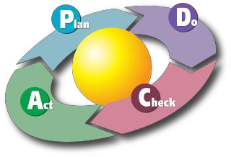
Figure 4-1: Plan-Do-Check-Act Diagram by Karn G. Bulsuk (http://www.bulsuk.com)

  - Cybersecurity

    - Basic Principles

Cybersecurity is a growing concern for US manufacturers as operational technology and information technology systems become increasingly interconnected. The integration of industrial control systems (ICS) with internet-connected devices enhances operational efficiency but also expands the attack surface for potential cyber threats. Ensuring a robust cybersecurity posture is essential to safeguarding sensitive data, maintaining operational integrity, and preventing disruptions.

Several organizations, including the US Federal Trade Commission (FTC), the US National Institute of Standards and Technology (NIST), and the US Department of Homeland Security (DHS),,, provide valuable resources to enhance cybersecurity practices. The following key cybersecurity principles should be prioritized:

- Adopt a Zero Trust Approach and implement strict access controls and continuously verify the identity and security status of users and devices.
- Use multi-factor authentication (MFA) and enforce role-based access control (RBAC) to minimize unauthorized access.
- Secure Data at Rest and in Transit, encrypt sensitive data and establish secure communication channels.
- Segment Networks and Isolate critical systems to limit lateral movement in the event of a breach.
- Deploy real-time monitoring and anomaly detection solutions to identify and mitigate cyber threats.
- Regularly update and patch software to address known vulnerabilities.
- Vet third-party vendors and require adherence to cybersecurity best practices.
- Prepare for potential breaches by having a comprehensive incident response strategy in place.

    - Dedicate Time to Learn About Threats and Mitigation

Cyber threats evolve constantly, making ongoing education and training essential. Organizations should allocate resources for cybersecurity awareness programs, ensuring employees recognize phishing attempts, ransomware threats, and social engineering tactics. Cybersecurity is a shared responsibility, and a well-informed workforce significantly reduces organizational risk.

    - Secure Remote access and Industry Control System (ICS):

Ensuring the security of remote access to Industrial Control Systems (ICS) is crucial for protecting critical infrastructure from cyber threats. Government agencies such as the Cybersecurity and Infrastructure Security Agency (CISA) and the National Institute of Standards and Technology (NIST) provide valuable guidelines for safeguarding these systems.

The Cybersecurity and Infrastructure Security Agency (CISA) emphasizes the importance of implementing strong encryption for remote access. It recommends using VPNs and secure communication protocols to protect data integrity and confidentiality. Organizations can follow CISA’s best practices to secure remote connections against unauthorized access and data interception.

While specific government publications may not directly address EDR solutions, the National Institute of Standards and Technology (NIST) Special Publication 800-82 provides comprehensive guidance on securing ICS environments. It includes recommendations for monitoring and detecting anomalous activities, which align with EDR solutions. NIST SP 800-82 also outlines the necessity of implementing robust access control measures to limit access to critical systems. Role-based access control (RBAC), multi-factor authentication (MFA), and network segmentation can help minimize unauthorized access risks. These controls play a vital role in preventing cyber threats from compromising ICS and SCADA environments.

Regular security audits and penetration testing are essential for identifying vulnerabilities in ICS environments before they can be exploited. NIST SP 800-82 recommends conducting routine assessments to strengthen resilience and improve cybersecurity defenses. Organizations should integrate proactive security testing to ensure ongoing protection against emerging threats.

    - Collaborate with Cybersecurity Communities and Initiatives

Cyber threats require a collective defense strategy. Companies can benefit from collaboration with cybersecurity-focused organizations such as:
- InfraGard: A partnership between the FBI and private sector organizations that facilitates intelligence sharing and enhances critical infrastructure security.
- CISA's Cybersecurity Resources: The Cybersecurity and Infrastructure Security Agency offers risk assessment tools, alerts, and best practices for critical infrastructure operators.
- ICS-CERT: The Industrial Control Systems Cyber Emergency Response Team provides vulnerability assessments and mitigation strategies for industrial sectors.

    - Leverage Advanced Cybersecurity Tools and Technologies

The National Institute of Standards and Technology (NIST) provides several authoritative resources that support the integration of advanced cybersecurity tools and technologies.
NIST has developed the Artificial Intelligence Risk Management Framework (AI RMF) to help organizations manage risks associated with AI systems, including those used for threat detection. This framework offers guidelines for incorporating trustworthiness considerations into the design, development, and deployment of AI technologies. ​
NIST defines Security Information and Event Management (SIEM) tools as applications that gather security data from information system components and present it as actionable information via a single interface. These tools are essential for aggregating and analyzing security data to identify potential threats. ​Also, NIST's publication on Zero Trust Architecture (ZTA) outlines principles for implementing zero trust strategies, emphasizing the need to move defenses from static, network-based perimeters to focus on users, assets, and resources. This approach ensures that no user or device is trusted by default, enhancing network security. ​
NIST supports organizations in achieving Cybersecurity Maturity Model Certification (CMMC) compliance by providing resources and success stories that highlight effective strategies for meeting cybersecurity standards required for government contracts. ​
By leveraging these resources, organizations can effectively integrate advanced cybersecurity solutions to enhance their resilience against evolving cyber threats.

- DATA CONFIDENTIALITY AND DISCLOSURE

This report is considered confidential. We only share this report with you and Rutgers University Field Management Team for Industrial Training and Assessment Centers. The field management team reviews the report for quality and will also conduct a customer service survey after we complete our own follow-up. For this purpose, we provide them with your contact information (please see Section 2.1). Additionally, data is entered into a publicly viewable database maintained by the field management team, including,
- Your corporate data (Section 2.2)
- Your facility’s annual utility consumption and production levels
- The summary data from the assessment recommendations (Table 1-1)
- Whether each AR was implemented (after follow-up survey)
Note that the name of the company, the precise location, and any other sensitive information will never be entered into the database nor shared.

Details of the APS E-35 rate plan (Last Accessed: 4/7/2024): https://www.aps.com/-/media/APS/APSCOM-PDFs/Utility/Regulatory-and-Legal/Regulatory-Plan-Details-Tariffs/Business/TOU-Business-NonRes-Plans/e35_TimeOfUseExtraLarge.ashx?la=en
APS rebates (Last accessed 4/9/2024): https://webtools.dnv.com/projects/Portals/15/APS_S4B_General_Measures_Quick_Look.pdf?ver=7DwSOmiyUXtvS42O6hwMuA%3d%3d
VFD Power consumption reference: Electric Power Research Institute, Adjustable Speed Drives Directory, Table 3.1, p18, 1991
Carbon dioxide reduction reference (Last accessed 4/13/2024): https://www.eia.gov/electricity/state/arizona/
200 hp VFD cost reference (Last accessed 4/13/2024): https://www.grainger.com/category/motors/motor-drives-speed-controls/variable-frequency-drives-accessories/variable-frequency-drives?attrs=Maximum+Output+Power%7C200+hp&filters=attrs
150 hp VFD cost reference (Last accessed 4/13/2024): https://www.grainger.com/category/motors/motor-drives-speed-controls/variable-frequency-drives-accessories/variable-frequency-drives?attrs=Maximum+Output+Power%7C150+hp&filters=attrs
125 hp VFD cost reference (Last accessed 4/13/2024): https://www.grainger.com/category/motors/motor-drives-speed-controls/variable-frequency-drives-accessories/variable-frequency-drives?attrs=Maximum+Output+Power%7C125+hp&filters=attrs
100 hp VFD cost reference (Last accessed 4/13/2024): https://www.grainger.com/category/motors/motor-drives-speed-controls/variable-frequency-drives-accessories/variable-frequency-drives?attrs=Maximum+Output+Power%7C100+hp&filters=attrs&gwwRemoveElement=true
APS Rebate reference (Last accessed 4/13/2024): https://webtools.dnv.com/projects/Portals/15/APS_S4B_General_Measures_Quick_Look.pdf?ver=7DwSOmiyUXtvS42O6hwMuA%3d%3d
Labor cost reference (Last accessed 4/13/2024): https://www.bls.gov/ooh/installation-maintenance-and-repair/electrical-and-electronics-installers-and-repairers.htm
Ozturk, M., and Dincer, I., 2022, “Utilization of Waste Heat from Cement Plant to Generate Hydrogen and Blend It with Natural Gas,” International Journal of Hydrogen Energy, 47(48), pp. 20695–20704.
Juangsa, F. B., Cezeliano, A. S., Darmanto, P. S., and Aziz, M., 2022, “Thermodynamic Analysis of Hydrogen Utilization as Alternative Fuel in Cement Production,” South African Journal of Chemical Engineering, 42, pp. 23–31.
APS Demand response plan (Last accessed 4/13/2024): https://www.aps.com/-/media/APS/APSCOM-PDFs/Utility/Regulatory-and-Legal/Regulatory-Plan-Details-Tariffs/Business/Rate-Riders/cpp-gen_CriticalPeakPricingRateRider.ashx?la=en
Implementation Cost Saving Grant (Last accessed 2/26/2026): ITAC Implementation Grants
Onsite Energy Program (last accessed 2/26/2026): Onsite Energy Program
Western Onsite Energy Program contact (last accessed 2/26/2026): Optony
Better Buildings Solution Center (last accessed 2/26/2026): Better Plants/Better Buildings
ISO website (Last accessed 4/13/2024): http://www.iso.org/iso/home/about.htm
ISO 50001 (Last accessed 4/13/2024): http://www.iso.org/iso/home/standards/management-standards/iso50001.htm
Better Buildings Program (Last accessed 4/13/2024): https://betterbuildingssolutioncenter.energy.gov/50001Ready
DOE Energy Management Programs (Last accessed 4/13/2024): https://energy.gov/ISO50001
Cybersecurity Basics (Last accessed 3/25/2025): https://www.ftc.gov/tips-advice/business-center/small-businesses/cybersecurity/basics
Small Business Information Security (Last accessed 3/25/2025): The Fundamentals, http://nvlpubs.nist.gov/nistpubs/ir/2016/NIST.IR.7621r1.pdf
The Industrial Control Systems Cyber Emergency Response Team (ICS-CERT) (Last accessed 3/25/2025): https://www.cisa.gov/uscert/sites/default/files/Monitors/ICS-CERT_Monitor_Jul-Aug2011.pdf
NIST principles (Last accessed 3/25/2025): https://csrc.nist.gov/publications/sp800
Managing Remote Access – CISA (Last accessed on 3/25/2025): https://www.cisa.gov/sites/default/files/2023-01/RP_Managing_Remote_Access_S508NC.pdf
NIST SP 800-82 (Last accessed on: 3/25/2025): https://csrc.nist.gov/pubs/sp/800/82/r3/final
InfraGard (Last accessed 3/25/2025): https://www.infragard.org/
IC3 (Last accessed 3/25/2025): https://www.ic3.gov/Outreach/PrivateSectorEngagement
CISA best practices (Last accessed 3/25/2025): https://www.cisa.gov/topics/cybersecurity-best-practices
Cybersecurity Advisories (Last accessed 3/25/2025): https://www.cisa.gov/news-events/cybersecurity-advisories
NIST AI Framework (Last accessed 3/25/2025): https://www.nist.gov/itl/ai-risk-management-framework
NIST SIEM Tool (Last accessed 3/25/2025): https://csrc.nist.gov/glossary/term/security_information_and_event_management_tool
NIST Zero Trust Framework (Last accessed 3/25/2025): https://www.nist.gov/publications/zero-trust-architecture
CMMC Model overview (Last accessed 3/25/2025): https://dodcio.defense.gov/Portals/0/Documents/CMMC/ModelOverview_V2.0_FINAL2_20211202_508.pdf

